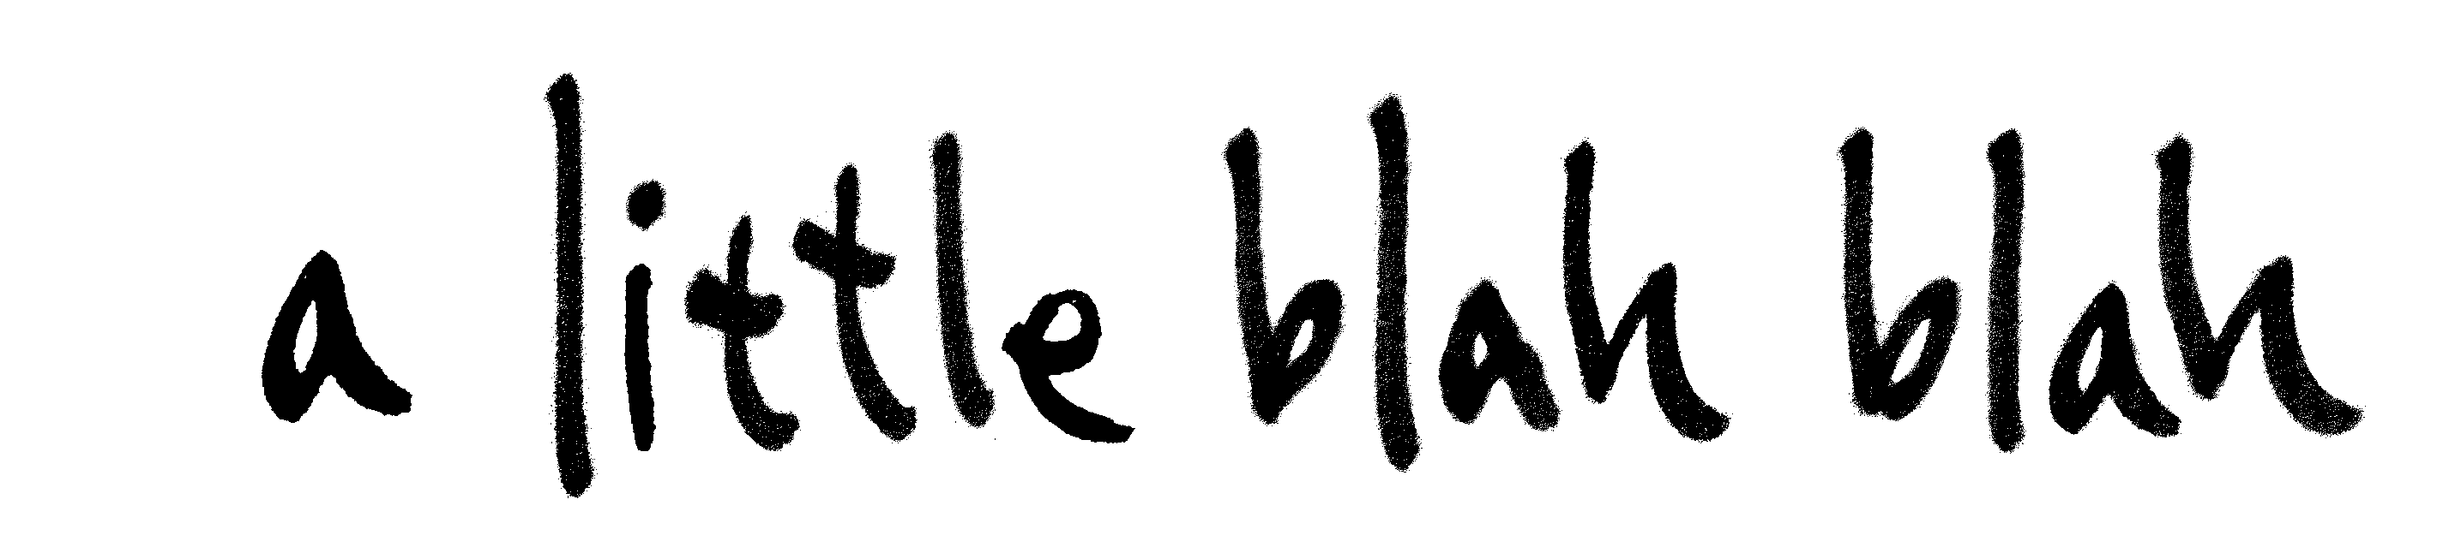

a little blah blah (albb) and Pi-Channel are pleased to present:

A window until the rains come
albb open studio program

APPLICATION FORM

To make an application for this program you will need to submit:
- This application form
- 1-page CV
- For all applicants except musicians: 5-10 digital images of recent work and an image list.
For musicians: a sound file with max. 5 mins of recent performances with a list

PERSONAL DETAILS

NAME
AGE
MALE / FEMALE
NATIONALITY
ADDRESS
PHONE
E-MAIL
WEBSITE/facebook/etc.

TYPE OF APPLICATION

What is your artistic practice / creative medium?

………………………………………………………………………………………..

I will apply as: (please select one of the following)
- an individual
- a group (please provide 1 page CV and personal details for all members of the group)
- a pair to share the space – (please provide 1 page CV and personal details for both members)

PROJECT PERIOD (March 1 – May 8)
Applicants can apply for a period from 6 – 12 days.
Number of days you wish to apply for: ………………………….

Please fill in your preferred dates between March 1 – May 8:
Note: your application period must include at least one weekend (Saturday+Sunday)

1st preference: from …………………… until …………………….
2nd preference: from …………………… until ……………………

PROJECT PROPOSAL

Please describe what you intend to do in Open Studio space (maximum ½ page)
…………………………………………………………………………………………..
…………………………………………………………………………………………..
…………………………………………………………………………………………..
…………………………………………………………………………………………..
…………………………………………………………………………………………..
…………………………………………………………………………………………..
…………………………………………………………………………………………..
…………………………………………………………………………………………..
…………………………………………………………………………………………..
…………………………………………………………………………………………..
…………………………………………………………………………………………..
…………………………………………………………………………………………..
…………………………………………………………………………………………..
…………………………………………………………………………………………..
…………………………………………………………………………………………..
…………………………………………………………………………………………..
…………………………………………………………………………………………..
…………………………………………………………………………………………..
…………………………………………………………………………………………..
…………………………………………………………………………………………..
…………………………………………………………………………………………..
…………………………………………………………………………………………..
…………………………………………………………………………………………..
…………………………………………………………………………………………..
…………………………………………………………………………………………..
…………………………………………………………………………………………..
…………………………………………………………………………………………..
…………………………………………………………………………………………..
…………………………………………………………………………………………..
…………………………………………………………………………………………..
…………………………………………………………………………………………..
…………………………………………………………………………………………..
…………………………………………………………………………………………..
…………………………………………………………………………………………..
…………………………………………………………………………………………..
…………………………………………………………………………………………..
…………………………………………………………………………………………..
…………………………………………………………………………………………..
…………………………………………………………………………………………..
…………………………………………………………………………………………..

OTHER

If you are applying from overseas, will this be your first visit to Vietnam?

Are you a Vietnamese speaker?

If you do not speak Vietnamese, would you be willing to pay a bilingual student a small fee to act as interpreter for you?

Does your application depend on your success in applying for funding? If so, to which funding bodies will you be applying, and when will you be notified?

How did you find out about this program?

PLEASE CHECK THAT YOU HAVE COMPLETED THE FOLLOWING DOCUMENTS AND SEND THEM WITH THIS APPLICATION FORM

For all applicants except musicians:
_ 1-page CV
_ 5-10 digital images of recent work (max. TOTAL file size, 2MB)
_ Image list (title, medium, date, dimensions)

For Musicians:
_ 1-page CV
_ Sound file of recent performances (max. 5 mins, 2MB)
_ A list with the title, date and location of these performances

---------------------------------

I have read, and understand the conditions of participation section below AND the information in the Call for Applications.

………………………………………………
Signature

CONDITIONS OF PARTICIPATION

Participating artists will be asked to sign an agreement that will detail conditions of participation, which include both the points outlined below and in the call for applications.

Artists will be requested to assist albb in the documentation of the project, as albb staff will only make occasional visits to the Open Studio.

Artists can work in the space in any reasonable manner that does not cause structural damage. Artists can drill into the walls in a reasonable amount –eg: to hang work etc. Work can also be stuck to the walls.

When vacating the space, artists are to leave the room in a condition similar to how they found it upon taking up occupancy. A condition report will be used, and artists are responsible for any damages they or their guests have caused. Artists will be required to vacate the space by 12 noon on the last day of their stay.

Artists are to take all due care with damage to Pi-Channel /albb property. Any damages made by the artists must be paid for by the artists.

While all reasonable care will be taken, neither albb nor Pi-Channel can be responsible for the safety of the artist, or their works or possessions left in the space for the duration of the project.

Artists behaving in an unreasonable or offensive manner, or who violate the terms of the contract, will be asked to leave the program.

HOW TO LODGE YOUR APPLICATION

Deadline for applications: Tuesday December 15, 2009

Please send all documents, via email, to: albb.openstudio@gmail.com

Make sure that the size of your application does not exceed 2MB

Thank you for your application

Applicants will be notified via email by Jan 15, 2010.

