Program Summary

Date | Section & Activity | Meeting Place | Time | Registration Contact
Saturday  12 Sep  -  Sunday  13 Sep | Excursion:  Mù Căng Chải National Heritage of Rice Terraces in harvesting time and Xuân Sơn National Park  English | Outside of the Sofitel Plaza Hotel; On Yên Phụ Rd, at the corner of Thanh Niên Rd | 7:30 AM  (2 days) | Mai  phmai@fpt.vn
Saturday  12 Sep | Music & Performance:  An Evening of Traditional Chèo performance | Tứ Liên Commune House, Tây Hồ Dist (near Sheraton Hotel) | 5:30 PM  (1.5 hrs) | Helen Huntley  helenshuntley@yahoo.com
Saturday  19 Sep  -  Sunday  20 Sep | Excursion:  Mid-autumn moon contemplation in Tan Mountain and Da River  English | Outside of the Sofitel Plaza Hotel; On Yên Phụ Rd, at the corner of Thanh Niên Rd | 2:00 PM  (1.5 days) | Mai  phmai@fpt.vn
Sunday  20 Sep | City Walks:  St Joseph’s Cathedral and the surrounding area  English | In front of St Joseph’s Cathedral  on the corner of Nhà Thờ and Nhà Chung streets | 9:30 AM  (2.5 hrs) | Loan  phuongloan2704@gmail.com
Tuesday  22 Sep | City Walks:  Lãn Ông Street  Japanese | 104 Hàng Đào Street | 9:30 AM  (2 hrs) | Yuko  herijapan@yahoo.co.jp
Sunday  27 Sep | Arts & Antiques:  Studio Opening  English | 5B/12 Đặng Thai Mai Street | 11:00 AM | Maureen  maureen.lewis2013@gmail.com

Friends of Vietnam Heritage (FVH) is a non-formal group of mainly Hà Nội residents from many countries who work voluntarily to promote and preserve Vietnamese cultural and historical heritage. With a cadre of dedicated volunteers and limited financial resources, FVH is proud to offer an array events like those listed above and detailed on the following pages.

Due to financial obligations incurred by FVH while planning events, please register for events in advance as space is limited. If you must cancel fewer than 24 hours before the event, or if you do not show up, you are kindly requested to pay the event fee.

Program Details

Excursion:
Mù Căng Chải National Heritage of Rice Terraces in harvesting time and Xuân Sơn National Park
Saturday, 12 September - Sunday, 13 September
(English)

Day 1
• 7.30 am start form Sofitel Plaza at. Drive via the highway 36 passing Sơn Tây City, Trung Hà Bridge, Thanh Sơn tea farm.
• 10.30 am arrived in Xuân Sơn National Park, Tân Sơn District, Phú Thọ Province. Short trek in the forest, taking photos of the lime stone forest and short rest and have a drink under the shade of jungle.
• Lunch at Guests House of the Xuân Sơn National Park
• 1.30 pm head back to the highway 36 continue drive to Nghĩa Lộ Town, on the way stop for short walk to the Mường house on still village, and taking picture of waterwheel complex for irrigation on the stream side.
• 4.30 – 5 pm Arrive in Nghĩa Lộ Town, Yên Bái Province. Check in Miền Tây Hotel.
• 7.00 pm: dinner , relax

Day 2
• Morning refresh and breakfast.
• 8.00 am check out the Hotel and drive toward Mù Căng Chải Distric. After leaving the town the marvelous rice terraces will go along on the way in Nam Bung, Tú Lệ, stop for photo and short walk to the field
• 9.30 am arrive at the biggest rice terrace in La Pan Tan, Mù Căng Chải. Walk to the field and the Hmong village on the valley. Continue drive to Kha Phạ Pass, and pass other rice terraces.
• 1.00 pm noon lunch in the local restaurant with mountain dishes.
• 2.00 pm leave Mù Căng Chải and drive back to to Hà Nội.
• 7.00 pm Back to Hanoi.

Place: Outside of the Sofitel Plaza Hotel; On Yên Phụ Rd, at the corner of Thanh Niên Rd
Cost: 2.300.000 VND per person including private group transport, 02 Lunch, 01 breakfast , 01 dinner , Twin Share Room at Miền Tây Hotel : www.mientayhotel.com.vn , entrance ticket if any, 2 bottles of waters and insurance.
Limit: 20 people
Registration: Mai , email : phmai@fpt.vn OR 0917-2949-23
Registration will close in 11 Sep 2015
Please leave your mobile number so you can be contacted in case of any last minute changes.

Notes:
• Kindly note that the accommodation is TWN room basis. If you wish to have SGL room, the Single Supplement is 250.000 VND per person
• If you have any special request for food, kindly let us know in your registration
• If you have any special note, kindly let us know in your registration
• If we do not have 7 people register the program, we will delay the program in another time
• Registration in 11 Sep will not available for insurance, other benefits of the excursion keep unchanged

Due to financial obligations incurred by FVH while planning events, please register for events in advance as space is limited. If you must cancel fewer than 24 hours before the event, or if you do not show up, you are kindly requested to pay the event cost.

Music & Performance:
An evening of Traditional Chèo Performance
Saturday, 12 September, 5:30 PM – 7:00 PM


Join us for a traditional Chèo performance in an atmospheric location. The event will showcase the stage, musical instruments, costumes, and typical characters of the “old” Chèo, with extracts from classic Chèo plays. In addition to enjoying performances by actors from the Việt Nam Chèo Theater, participants will also have the opportunity to enact their favorite characters.

Hát chèo is a form of popular musical theatre dating back to the 11th century. Appreciated especially in the northern part of the country, the historical plays and social satires portray village characters such as farmers, herdsmen, craftsmen, and landowners. In addition, the singers also play the roles of clowns, drunks, and madwomen, criticizing and making fun of the village authorities in their performances. The traditional Hát Chèo musical ensemble consists of two-string fiddles, flute, and drums while modern re-creations use more instruments. The following You Tube videos illustrate Chèo music and performance.
https://www.youtube.com/watch?v=ViXpzeEHCU8&index=1&list=RDViXpzeEHCU8
https://www.youtube.com/watch?v=BOXR9W-_3g8

This non-profit program is introduced by the “I Move” cultural media project in cooperation with the Việt Nam Chèo Theater.

Place: Tứ Liên Commune House, Tây Hồ Dist (near Sheraton Hotel)
Cost: 100,000 VND
Limit: 10 people
Registration: Helen Huntley, helenshuntley@yahoo.com
Please note that tickets will be purchased in advance for this event. If you sign up and then cancel or do not show up for the event, you will be liable for the full price of the ticket.

----------------------------------

Excursion:
Mid-autumn moon contemplation in Tản Mountain and Đà River
Saturday, 19 September, 8:00 AM - Sunday, 20 September, 5:30 PM
(English)

Day 1
Saturday 19 Sep 2015
• 2.00 pm: Drive to Thanh Thủy District, Phu Tho Province. This Town situated on the bank of Đà River reflecting great Tản Viên Mountain on the opposite site.
• 3.30 pm: Arrive at Thanh Thủy District and check in Tre Nguon Resort.
• 5.00 pm: Continue drive to visit Hoàng Xa wooden hundreds year old church in Thanh Thủy Town, then drive along Đà River to taking picture and admire the Landscape of Da River and Tản Viên Mountain. Enjoy sunset drink on the river site and the moon rise of mid-autumn
• 7.00 pm: back to the resort and having dinner and relax.
• Stay overnight at the resort.

Day 2
Sunday 20 Sep 2015
• 7.30 am: breakfast in the resort
• 8.30 am: check out the resort and drive back to Sơn Tây City, then turn to Ba Vì National Park. Go up to the top of the mountain, trekking in the forest visit Upper Temple and Hồ Chí Minh Temple.
• 12.30 pm: Lunch in a restaurant of the National Park.
• 2.00 pm: leave the Park and drive back.
• 5.00 pm back to Hanoi

Place: Outside of the Sofitel Plaza Hotel; On Yên Phụ Rd, at the corner of Thanh Niên Rd

Cost: 1.900.000 VND per person including private group transport, 01 Dinner , 01 breakfast , 01 Lunch , Twin Share Room at Tre Nguon Resort : www.trenguonresort.com , entrance ticket if any, 2 bottles of waters and insurance
Limit : 16 people
Registration: Mai, phmai@fpt.vn or 0917-2949-23

Notes:
- Kindly note that the accommodation is TWN room basis. If you wish to have SGL room, the Single Supplement is 450.000 VND per person
- If you have any special request for food, kindly let us know in your registration
- If you have any special note, kindly let us know in your registration
- If we do not have 6 people register the program, we will delay the program in another time

Registration in 17 Sep will not available for insurance, other benefits of the excursion keep unchanged

----------------------------------

Discover Hanoi City Walk:
St Joseph’s Cathedral and the surrounding area
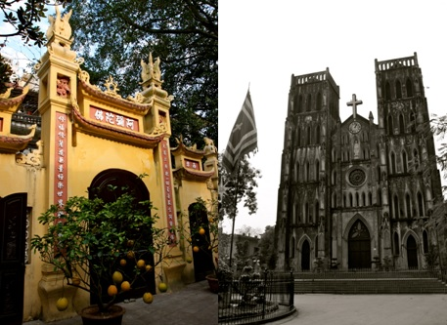
Sunday, 20 September, 9:30 AM – 12:00 PM
(English)

This walk commences at St Joseph’s Cathedral and travels through some of the streets of the Old Quarter, including Lý Quốc Sư, Yên Thái, Hàng Quạt, and Hàng Trống. It also includes visits to two important temples (or Đền) and two community houses (or Đình).

Place: St Joseph’s Cathedral on the corner of Nhà Thờ and Nhà Chung streets
Cost: 70,000 VND
Limit: 8 people
Registration: Loan, phuongloan2704@gmail.com
Please leave your mobile phone number so we can contact you in case of any last minute changes.
Note: Wear comfortable shoes and clothes as it may be hot or rainy, and bring plenty of water to drink.

----------------------------------

Discover Hanoi City Walk:
Lãn Ông Street
Tuesday, 22 September, 9:30 AM - 11:30 AM
(Japanese)

We will visit the old quarter such as the herbal medicine street, the building where Hồ Chí Minh wrote the Declaration of Independence and the shooting locations of the film “The Quiet American” and so on. Let’s explore alleys in the old quarter! This walk is going to be conducted in Japanese.

Place: 104 Hàng Đào Street
Cost: 70,000 VND
Limit: 8 people
Registration: Yuko, herijapan@yahoo.co.jp
Please leave your mobile phone number so we can contact you in case of any last minute changes.

Arts & Antiques:
Studio Opening
Sunday, 27 September, 11:00 AM - 12:30 PM
(English)

FVH invites you to the Open Studio of two artists living and painting in Hanoi. George and Ilza Burchett will meet you at their studio/home where you can view their art and talk with the artists about the works.

Artist George Burchett was born in Hà Nội in 1955. His father was legendary Australian journalist Wilfred Burchett. George grew up in Moscow, Phnom Penh and Paris. He studied art in Paris and graduated with a Masters in Mural Art from the Fine Arts Academy in Sofia, Bulgaria. He has worked on large art projects and exhibited in Europe, Australia, South East Asia and China. Since 2011 he resides in Ha Noi.
His current artistic interest is Vietnam's legendary virgin warrior and early feminist Ba Trieu (225-248 AD) who pronounced these immortal words:
"I want to ride on the great winds to capture the sharks in the open sea, drive away invaders and free the country, destroy the bonds of slavery and not bend my spine to be concubine to anyone."
You can see George's works on his website: www.georgeburchett.com
* * *
Ilza Burchett was born in Bulgaria and grew up in Moscow, Russia. She studied painting and mural art at the Fine Arts Academy in Sofia, Bulgaria from 1973 to 1978 and graduated with Master of Fine Art. Since then she works as an artist and has exhibited in Europe, Australia, South East Asia and China.
Her art is abstract -- in its meaning is oriented towards ontological questions of being -- and finds its reasons and inspiration in the history of art, in the primordial primitive aboriginal culture of Australia, the contemporary Western philosophical thought and Taoist philosophy, modern mathematics (set theory) and Nature, and her practice of Wudang Tai Chi Quan (internal martial arts).
Since 2012 she is based with her family in Hanoi, Vietnam, where she also writes art reviews for The Hanoi Grapevine.
Her works are in corporate, public and private collections in Australia, Europe, Asia and the USA. You can see some of her work on: www.ilzaburchett.com or at her Sydney gallery Art Atrium: http://www.artatrium.com.au/exhibition19/p1.html

Place: 5B/12 Đặng Thai Mai Street
Cost: 100,000 VND
Registration: Maureen, maureen.lewis2013@gmail.com
Please leave your mobile phone number so we can contact you in case of any last minute changes.

Get Involved, Volunteer!

Guidebook Research and Revision
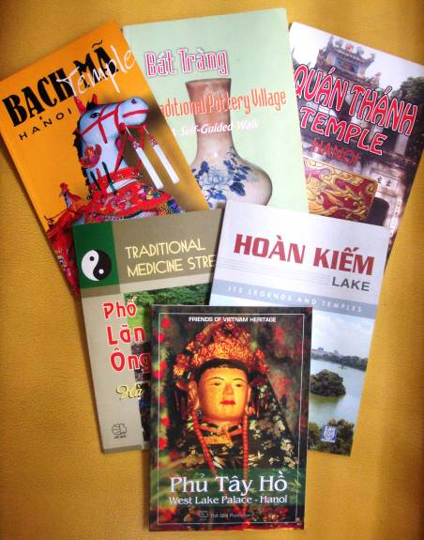
The Friends of Vietnam Heritage Publications group is asking for 4 volunteers to help with research and revision of one of FVH's guidebooks. Each volunteer will be assigned a walk or area for review. Research time can be flexible depending on your schedule and each area should take 2 to 4 hours. Two organizational meetings will be held later to review and present changes to publisher.

For more information: Please email John Reilly, lefthanded2hanoi@yahoo.com

Walking Guide
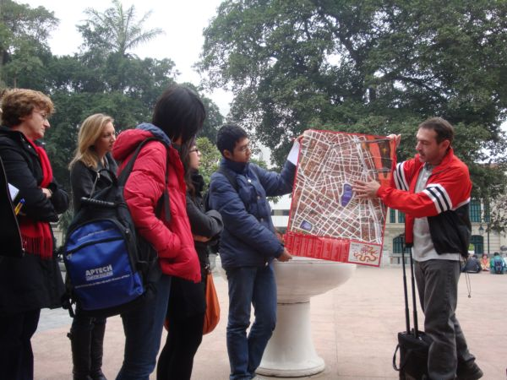
Have you ever been on one of FVH’s fabulous walks and thought to yourself: “Wow! I want to be a guide just like that!”? Well, now you too have the chance – we have a very limited number of walks that need guiding, and you could be the lucky person to guide one of these walks!

Main duties once every 3-6 months:
- Schedule the walk by sending in a pre-written template to the FVH newsletter publisher
- Register and keep track of attendees
- Send out a reminder e-mail before the walk
- Guide the walk, check-in attendees, and collect the event fee
- Submit a follow-up report

Expected output: One activity every 3-6 months (except during summer months)
Estimated time: 3 hrs per month
For more information: Please email fvh.citywalks.english@gmail.com

Museum Spotlight

Vietnam Museum of Ethnology
Bảo Tàng Dân Tộc Học Việt Nam
Nguyễn Văn Huyên Road, Cầu Giấy, Hà Nội
Tel: (84-4) 3756-2193
Email: vme18@vme.org.vn
www.vme.org.vn

Bus Routes: 7, 14, 27, 28, 30, 38, 45
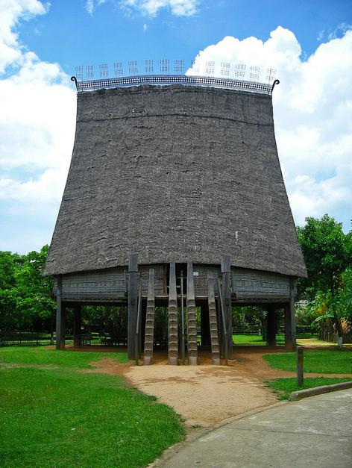
Hours: 8:30 AM - 5:30 PM daily except Mondays
Ticket Price: 25,000 VND for regular admission
5,000 VND for children and students
Free for children under 6 years of age and people of Việt Nam ethnic minorities
Tour Prices: 30,000 VND for tours in Vietnamese, 50,000 VND in French and English
Water Puppets: Performances every Saturday and Sunday at 10:00 AM, 11:30 AM, 2:30 PM and 4:00 PM. Show tickets are 40,000 VND for adults, 10,000 VND for children, children under six are free, 15,000 VND for student. This fee is in addition to the regular museum entrance fee and goes directly to the puppet troupe. After the performances there are opportunities to talk to the artisans about traditional puppetry in Việt Nam. The performance is held in the outdoor exhibition space. Special performance for private parties and events can be arranged.

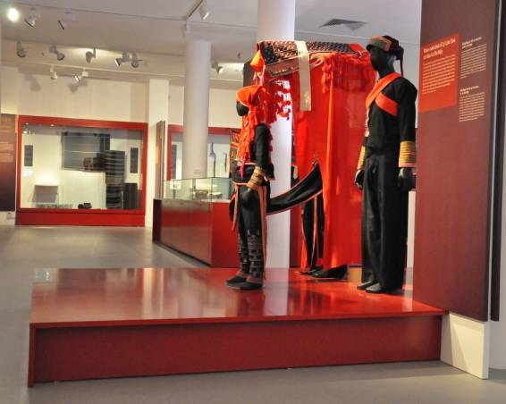
The Vietnamese Women’s Museum
Bảo Tàng Phụ Nữ
36 Lý Thường Kiệt, Tel: (84-4) 3825-9936
www.baotangphunu.org.vn

Bus Routes: Any bus that runs on Lê Duẩn,
Hai Bà Trưng, or Trần Hưng Đạo
Hours: Daily from 8:00 AM - 4:30 PM
Ticket Price: 30,000 VND for Expats

Hanoi Museum
Bảo Tàng Hà Nội
Phạm Hùng Street, Từ Liêm

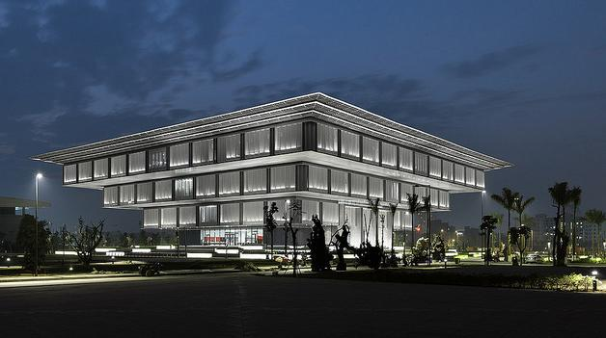
The first two floors of the Vietnam National Museum of History house a permanent collection of bronzes, photos, plants, pottery and miscellaneous artifacts, along with a small cafe and shop. At the entrance to the second floor exhibits there is magnificent silk embroidery. The third and fourth floors are still under development but currently display an extensive temporary collection of ceramic pieces from 1000BC to the 20th Century, Đông Sơn drums and both metal and stone tools.

This new museum is completely wheelchair accessible. There is a ramp on the left of the stairs leading to the front door and a circular ramp spirals to each of the four floors. There is also an elevator.

Items are labeled in both Vietnamese and English and are well lit and displayed. Groups are welcome.

Location: Next to the Conference Center near the Mỹ Đình National Stadium
Hours: 8:30-11:30 AM, 2:00-4:30 PM. Closed on Mondays.
Admission: Free until further notice. English Translator available, donation requested
Bus Routes: 5, 29, 33, 39, 44, 50
"Antique Market"

Date: 01 February
Location: Hanoi Museum, Phạm Hùng St., Hanoi
Time: 9:00am-4:30pm

Glimpse of the Past Antique Market, sponsored by the Hanoi Museum, has strict guidelines for vendor selection and monitoring of merchandise. The market is organized with the support and advice from members of the Thang Long Antiques Society. More than 70 booths display various objects from the recent and and more distant past, as well as from famous craft villages. Booth owners come from Hanoi and its surrounds.

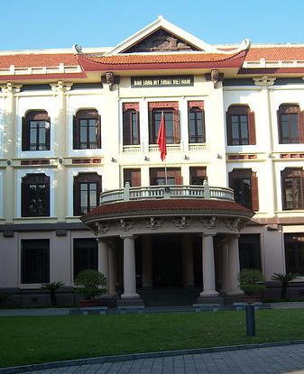
Vietnam Museum of Fine Arts
Bảo Tàng Mỹ Thuật
66 Nguyễn Thái Học, Tel: (84-4) 3823-3084
www.baotangmythuat.vn

Bus Routes: 2, 18, 23, 25, 27, 32, 34, 38, 39, 41, 45, 50
Hours: 8:30 AM – 5:00 PM daily
Ticket Price: 20,000 VND for adults
7,000 VND for students and children under 12
FVH Liaison: John Reilly, lefthanded2hanoi@yahoo.com

The Vietnam Museum of Fine Arts has an excellent collection of the following:
- Fine arts in the early historic times, pre-11th century
- Religious art
- Fine arts from 11th to 19th century
- Paintings and sculptures from the 20th century
- Lacquer paintings
- Paintings on silk
- Applied decorative arts
- Vietnamese ceramics from 11th to 20th century

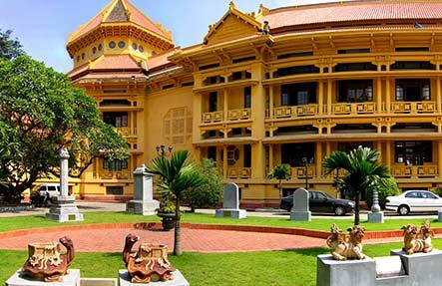
The National Museum of Vietnamese History
Bảo Tàng Lịch Sử
1 Tràng Tiền Street,
Tel: (84-4) 3824-1384 / 3825-7753
Email: banbientap@nmvnh.org.vn
www.baotanglichsu.vn

Bus Routes: 2, 3, 4, 9, 11, 23, 34, 36, 40, 45
Hours: 8:30 AM – 11.30 AM & 1.30 PM - 4:30 PM
(daily except Monday)
Guided tours: Available on request
Guide Contact: Mrs Nguyen Thu Hoan, Deputy of Exhibition and Education Department, office: (84-4) 824-1384,
"Đông Sơn Culture" Exhibition

Open: 18 Nov 2014
Location: The National Museum of Vietnamese History
mobile: (84) 094-536-8086
tuyentruyenbt@baotanglichsu.vn
Ticket Price: 20,000 VND for adults
10,000 VND for students
2,000 VND for children
Photo/Video Charges:
Video: 800,000 VND per day if showcases are opened; 400,000 VND per day if showcases are not opened
Research photographs: 20,000-600,000 VND per day (depending on needs)
Personal video: 30,000 VND
Personal camera: 15,000 VND

Publications

Friends of Vietnam Heritage produce a number of publications. All publications are 60,000 VND. If you would like to purchase any of these books just contact FVH at fvheritage@gmail.com. Books are also sold at all FVH events or at Bookworm.

1. Bạch Mã Temple Guidebook (White Horse Temple)
Learn about King Lý Thái Tổ’s dream and why the temple honors the White Horse Deity. This guidebook offers detailed information on the history of Bạch Mã Temple on Hàng Buồm Street, including temple layout, translation of panels written in Chinese characters, as well as information about the symbolism used in the temple. The guided walk contained at the end of this guidebook provides an opportunity to explore and experience some of the same streets where the craft guilds and merchants set-up within the third enclosure of the citadel.
Published 2001

2. Quán Thánh Temple Guidebook
This publication details the legends of Huyền Thiên Trấn Vũ, also known as the ‘genie who guards the Dark Heaven.’ This guidebook contains detailed information on the history of Quán Thánh Temple, as well as translations of the many parallel sentences and poems on the walls and columns of this magnificent Taoist Temple. A walking tour of the bronze-casting village of Ngũ Xã, with its Chùa and Đình and the enjoyable atmosphere around Trúc Bạch Lake is included. Published 2002, reprinted 2008

3. Trấn Quốc Pagoda Guidebook
The Trấn Quốc Pagoda on Thanh Niên Road was founded some 1400 years ago, and it is one of the most ancient Buddhist pagodas in Hà Nội. Nestled between West Lake and Trúc Bạch Lake, the pagoda is considered a magnificent symbol of Buddhism in Việt Nam, and is one of the most visited sites in the capital. This guidebook covers the history of Buddhism, the temple layout, and describes in detail the different areas of the pagoda. A fascinating publication, which includes especially commissioned drawings and photographs.
Published 2003, reprinted 2006

4. Phủ Tây Hồ Guidebook (West Lake Palace)
Have you ever wondered who these doll-like statues in glass cabinets, in blue, white, red or green attire may be? Phủ Tây Hồ at the far end of the Tây Hồ peninsula is the most impressive pagoda dedicated to the cult of the Mother goddesses in Hà Nội, an indigenous cult that seems to permeate the lives of all Vietnamese women in varying degrees. The guidebook describes in detail the complex itself, then discusses the religion of the Mother goddesses, including its philosophy, pantheon and rituals. Published 2004

5. Lãn Ông Street Guidebook (Traditional Medicine Street)
Traditional medicine is very much alive on this particular street of the Old Quarter. This guidebook not only describes the area in its historical context and current set-up, but also offers information on a variety of Vietnamese herbal teas for the health conscious as well as a comprehensive pictorial of Lãn Ông Street. Published 2005, reprinted 2005

6. Bát Tràng Traditional Pottery Village: A Self-Guided Walk
This guidebook focuses on the old section of the pottery commune of Bát Tràng, a village with a long history hitherto unknown to many outsiders. The guidebook is based on a self-guided walk. There are three different circuits lasting from 45 minutes to two hours, all shown on a map. Published 2006, reprinted 2009

7. Hoàn Kiếm Lake, its Legends and Temples: A Self-Guided Walk
The area around Hồ Hoàn Kiếm represents the physical heart and spiritual soul of Hà Nội. Continuing the tradition of FVH to promote the understanding of Việt Nam's history and culture, this guidebook focuses on the history and legends, the temples and pagodas surrounding the lake. Also included is information on the large Báo Ân Pagoda complex, which was razed between 1886-1889 and left only the Hòa Phong tower still standing today. Published 2007

8. Vignettes of French Culture in Hà Nội
This guidebook provides an insight and appreciation of the influence on Hà Nội of the French colonial period from 1873 until 1954. The three guided walks contained in this guidebook provide an opportunity for the reader to explore and experience aspects of what the people of Hà Nội have absorbed and made their own as a result of eighty years of French presence in their city. Published 2008

9. Hồ Tây – Walks Around West Lake
Hồ Tây continues to inspired writers, artists and photographers with its beauty, history, culture and religious aspects, but it also provides for its local residents a source of fish, water and a rich soil to cultivate a variety of plants and vegetables. This guidebook covers the legends of the lake, as well as its history and future plans for this rapidly expanding part of Hà Nội. Included are five self-guided walks identifying those places of interest both old and new around the entire West Lake shore. Published 2009

10. Văn Miếu Walking Tour (Temple of Literature)
This guidebook introduces visitors to the Văn Miếu, or the Temple of Literature, one of the foremost architectural treasures of Việt Nam and its capital city Hà Nội. The Văn Miếu - Quốc Tử Giám ranks third in Việt Nam's register of national historic sites. A leafy oasis in the centre of the bustling city, it is a magnet for the citizens of Hà Nội and for visitors to the city who wish to spend a quiet moment contemplating its rich past. This guidebook contains a history of the school and the temple, a description of each courtyard and its meaning as expressed through its architecture, translations of all the plaques, as well as quick guides to Confucianism and the Royal Examinations
Published 2010

Resource Center

Hanoi City Library
Thư Viện Hà Nội
47 Bà Triệu, 4th floor
Hà Nội, Việt Nam

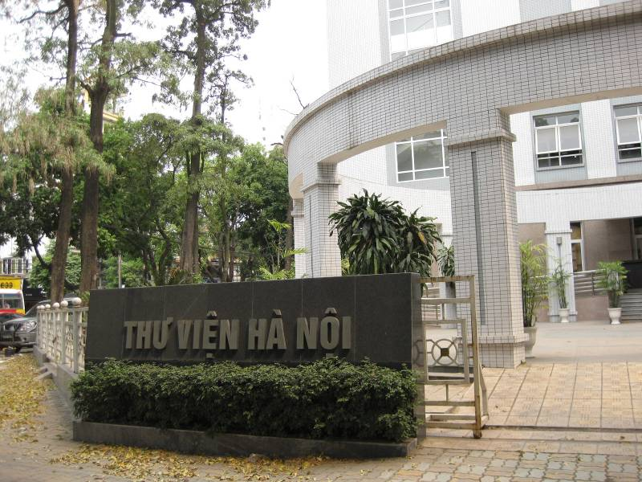
The Friends of Vietnam Heritage’s Resource Center is on the 4th floor of the Hanoi City Library (Thư Viện Hà Nội), located on the corner of Trần Hưng Đạo and Bà Triệu streets. The FVH collection includes books and journals that focus on Vietnamese art, history and culture.

In order to access the collection you need to get a Reader’s Card. Go to the office (just inside the main entrance of the library), fill out a simple form, and attach one photograph. You’ll also need to show your passport and pay an annual fee of 22,000 VND. After becoming a member, show your card whenever you go in.

The FVH collection is for reference only. You cannot remove the books from the library. Please note that the Reader’s Card does not authorize the holder to borrow other books from the main library. If you want a Borrower’s Card for checking out non-FVH books, you will need to fill out another form to receive one.

Library Opening Times: Every day Monday to Friday except Thursday morning of the first and third week of the month. Daily times: 8:00 AM – 12:00 PM and 1:30 – 5:00 PM. Closed on weekends and national holidays.

Moving?
Say goodbye to FVH by leaving us your gently-used books about Việt Nam. Your donation will be added to our reference collection, housed inside the FVH Resource Centre, Hanoi City Library. Contact John Reilly (lefthanded2hanoi@yahoo.com) to arrange donation. Your books will be enjoyed by many people for years to come—thank you!

The Last Page

Friends of Vietnam Heritage (FVH) is a non-formal group of mainly Hà Nội residents from many countries, including Việt Nam. FVH’s purpose is to enjoy, enhance and deepen the understanding of Việt Nam’s cultural and historical heritage and thereby help with its preservation. There is no membership fee to join.

Website: www.fvheritage.org
Bookmark the Friends of Vietnam Heritage website where you will find the monthly program and further information about FVH, including a photo page and links.

Email: fvheritage@gmail.com
Address all correspondence to the Friends of Vietnam Heritage email address.

Program: To receive our free monthly program, please send an email to fvheritage@gmail.com.

Participation: Our programs are open to all people. FVH programs and events are in English or translated into English, unless noted otherwise.

Volunteering: If you are interested in serving on the FVH Governing Council or in volunteering for a specific section, please send an email to fvheritage@gmail.com. Also visit the “Get Involved” section of our website for current volunteer openings. FVH does not have an office, so all volunteers work from home.

Council Meetings: The FVH Council usually meets every first Tuesday of the month at the Fine Arts Museum. However, times and dates may change. Everyone who receives this program is welcome to attend the meetings as an observer. If you are interested in attending, please email fvheritage@gmail.com to verify date and time.

Executive Committee: John Reilly - Chair; Yuko - Treasurer
Helen Huntley - Vice Chair;

Student Invitation
FVH would like to invite Vietnamese students to join our events for half of the activity cost. Please contact the event coordinator to reserve a place (subject to availability, as determined by the coordinator). Students are required to present their current student identification card.

Off the Record, Disclaimer
All FVH activities, especially the lectures and discussions, are considered “off the record” and as such, may not be quoted in the press or other format. Exceptions will only be considered when proper requests for permissions and arrangements have been made beforehand with FVH and the individual speaker. In addition, all statements made during FVH programs belong to the individual presenter(s) and as such do not reflect the views or opinions of the organization, council or members of FVH.

HOPE TO SEE YOU AT OUR EVENTS!
To receive this program by email, subscribe by sending an email to: fvheritage@gmail.com
If you no longer with to receive our program by email, please reply to fvheritage@gmail.com
with “UNSUBSCRIBE” in the subject line.

-END-

